Results

Km values were from measurements were glucose-6-phosphate concentrations were varied from 50 μM to 400 μM, while the NADP+ concentrations were between 20 μM and 150 μM. The resulting Km values for NADP+ and glucose-6-phsophate are listed in Table 1. Ki values of NADPH were determined with one substrate kept at a constant concentration, while the second substrate was varied at different constant inhibitor concentrations. According to the determined sequential ordered bi-bi-mechanism it was expected that NADPH will inhibit competitively in respect to NADP+ and mixed non-competitive with respect to glucose-6-phosphate [1]. To determine the respective inhibition constants, reaction velocities were determined under different NADPH concentrations (150, 75 and 0 μM), the glucose-6-phosphate concentration was held at 400 μM and NADP+ was varied from 10 to 60 μM or alternatively NADP+ was held at 40 μM and glucose-6-phosphate was varied from 50 to 400 μM. The resulting inhibition constants and intracellular concentrations are indicated in Table 1.

|  |  |  |
| --- | --- | --- |
| Table 1 Experimentally determined kinectic parameters and intracellular metabolite concentrations | | |
|  | Own data  [μM] | Olavarria et al [5]  [μM] |
| ***Substrate Km*:** |  |  |
| NADP+ | 23 | 7.5 ± 0.8 |
| glucose-6-phosphate | 136 | 174 ± 11 |
| ***NADP+ dissociation Ki*:** |  |  |
| NADP+ | 90 | 19 ± 4 |
| ***NADPH inhibition Ki*:** |  |  |
| Kic,NADP+ | 35 | 14 ± 2 |
| Kic,glucose-6-phosphate | 100 | 101 ± 9 |
| ***Intracellular Concentrations*** |  |  |
| **wild-type** |  |  |
| Glucose-6-phosphate | 289 ± 2 | 801 |
| NADP+ | 581 ± 13 | 21-210 |
| NADPH | 191 ± 20 | 24-220 |
| **Δ*pgi*** |  |  |
| Glucose-6-phosphate | 3301 ± 41 | - |
| NADP+ | 400 ± 31 | - |
| NADPH | 211 ± 9x | - |

For the initial rate predictions using intracellular metabolite concentrations shown in Figure 2, the rate laws (equations 1 & 2) describing the forward reaction in the presence of both educts and products were used that were previously published for glucose-6P dehydrogenase in *E. coli* (1). Only the forward reaction with NADPH inhibition was simulated since the 6P-gluconolactone produced reacts rapidly further to 6P-gluconate and in addition is very instable [2].

Methods

*Quantification of intracellular metabolite concentrations*

All measurements were carried out on an Agilent 1100 Series HPLC system coupled with an Applied Biosystems / MDS SCIEX 4000 Q TRAP™. Data were recorded and analyzed with Analyst Software Version 1.4.2 Build 1228. Chromatographic separation was achieved on a Phenomenex Hydro RP 150 mm x 2.1 mm x 4 μm column at 40°C using an adapted version of a published protocol [3]. Briefly, the injected volume was 8 µl, and the mobile phase at a flow rate of 200 µl/min was directly introduced into the mass spectrometer via electro spray ionization (ESI). The gradient profile was linear with two phases (Table 1), where solution A was 10 mM tributylamine and 15 mM acetate in H2O (pH 4.95) and solution B was 100 % methanol. Multiple reaction monitoring (MRM) settings were optimized individually for each metabolite except 6P-gluconolactone for which the MRM settings were adapted from 6P-gluconate [3].

|  |  |  |  |
| --- | --- | --- | --- |
| **Table 1** - Gradient profile applied for the LC-MS/MS method | | | |
| Step | Total time (min) | Eluent A (vol.%) | Eluent B (vol.%) |
| 1 | 0 | 100 | 0 |
| 2 | 15 | 45 | 55 |
| 3 | 27 | 34 | 66 |
| 4 | 28 | 0 | 100 |
| 5 | 33 | 0 | 100 |
| 6 | 35 | 100 | 0 |
| 7 | 55 | 100 | 0 |

*Characterization of Glucose-6-phosphate dehydrogenase*

Glucose-6-phosphate dehydrogenase was overexpressed in 50 ml LB medium with 0.1 mM IPTG and 25 mg/L chloramphenicol at 37°C and 250 rpm from an overexpression plasmid obtained from the ASKA clone collection [4]. Cells were harvested by centrifugation and the pellet was washed twice with 2 ml 0.9% NaCl with 10 mM MgSO4. The pellet was then resuspended in 4 ml ice cold 100 mM Tris-HCl pH 7.5, 5 mM MgCl2 supplemented with Protease-Inhibitor (Complete EDTA-free, Roche) and 1 mM DTT. Cells were disrupted by passage through a precooled French press mini cell at 1000 PSI and the crude extract was subsequently centrifuged for 30 min at 23000 x g and 4°C to obtain a clear cell lysate. The lysate was then loaded on a 1ml HisTrap HP columns from Amersham Biosciences. The column was washed with 12 volumes of wash buffer (20 mM NaH2PO4 pH 7.5, 500 mM NaCl, 10 mM Imidazole, 15 mM β-Mercaptoethanol) and then the protein was eluted using increasing imidazole concentrations. Fractions containing pure protein were buffer-exchanged against 100 mM Tris-HCl pH 7.5, 10 mM MgCl2 and 15 mM β-Mercaptoethanol using 25 kD Spectra-Por Float-A-Lyzer.

All enzyme assays were run at 30°C in 100 mM Tris HCl pH7.5 and 10 mM MgCl2 on a Spectramax Plus spectrometer (Molecular Devices). Absorbance was recorded at 340 nm with 2 second interval single measurements in 1 ml cuvettes. Purified enzyme was equilibrate with cofactor until absorbance at 340 nm was stable. The measured absorbance curve over time was regressed with a second order polynomial to determine the initial velocity at the time point when the second substrate was added and the sample was mixed. The Km values for NADP+ and glucose-6P and the Ki value for NADPH were then obtained by varying respective substrate or inhibitor concentrations and analysis by primary and secondary Lineweaver-Burk plots assuming a sequential two-substrate mechanism [1]:

|  |  |
| --- | --- |
|  | (1) |

Inhibition by NADPH was determined to be competitive with respect to NADP+ which can be included by the following inhibitory terms (1):

|  |  |
| --- | --- |
|  | (2) |

Supplemental Figures

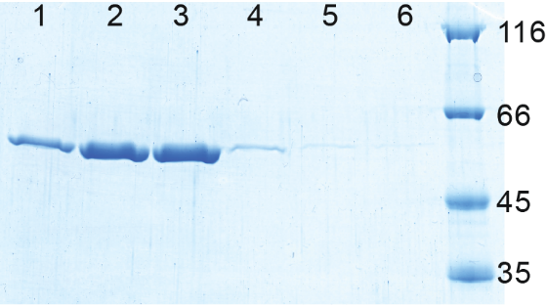

**Suppl. Figure 1** SDS-PAGE of overexpressed and His-Tag purified glucose-6P dehydrogenase (~56.8 kD including His-Tag). The pure enzyme was eluted with different imidazole concentrations (lanes 1 to 6: 100-200, 200, 200-300, 300, and twice 500 mM imidazole). Fractions in lane 2 and 3 were pooled for further analysis.

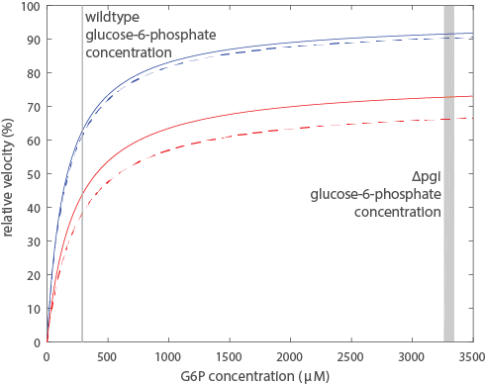

**Suppl. Figure 2** Simulated initial reaction velocities for glucose-6-phosphate dehydrogenase using rate laws without NADPH inhibition (Equation 1) and with NADPH inhibition (Equation 2). Experimentally determined kinetic parameters and intracellular cofactor concentrations were used (Table 1). Intracellular concentrations from wildtype and from pgi knockout are shown with solid and dashed lines respectively. Actual intracellular glucose-6-phosphate concentrations for wildtype and *pgi* knockout are indicated by the grey bars.

**References**

1) Chassagnole, C., et al., *Dynamic modeling of the central carbon metabolism of Escherichia coli.* Biotechnology and Bioengineering, 2002. **79**(1): p. 53-73.

2) Bauer, H. P., T. Srihari, J. C. Jochims, and H. W. Hofer. 1983. 6-phosphogluconolactonase. Purification, properties and activities in various tissues. Eur. J. Biochem. 133:163-168.

3) Luo, B., K. Groenke, R. Takors, C. Wandrey, and M. Oldiges. 2007. Simultaneous determination of multiple intracellular metabolites in glycolysis, pentose phosphate pathway and tricarboxylic acid cycle by liquid chromatography-mass spectrometry. J. Chromatogr. A 1147:153-164.

4) Kitagawa, M., T. Ara, M. Arifuzzaman, T. Ioka-Nakamichi, E. Inamoto, H. Toyonaga, and H. Mori. 2005. Complete set of ORF clones of Escherichia coli ASKA library (a complete set of Escherichia coli K-12 ORF archive): unique resources for biological research. DNA Res. 12:291-299.

5) Karel Olavarrı´a, Diego Valde´ s and Ricardo Cabrera, The cofactor preference of glucose-6-phosphate dehydrogenase from Escherichia coli – modeling the physiological production of reduced cofactors. FEBS Journal 279 (2012) 2296–2309